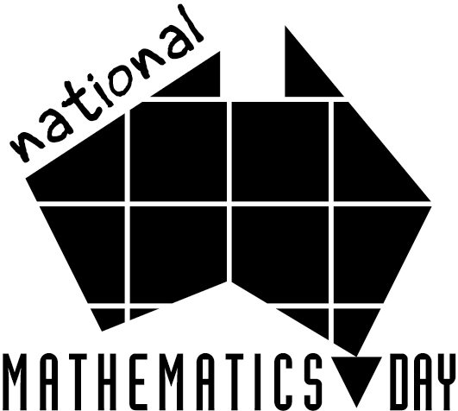

Dear Families
For National Mathematics Day 2013, we will be investigating the heritage and family origins of the students in our class.
We would like to know what your family’s origins are and we will be discussing these in class. If your families did immigrate to Australia, you may like to share stories with your children about how and why that happened. We would also like to hear stories from families who have moved homes within Australia.
It doesn’t matter how far back into family history you go, it is more important that students collect data which are meaningful for them. You can use the map below to identify the countries.

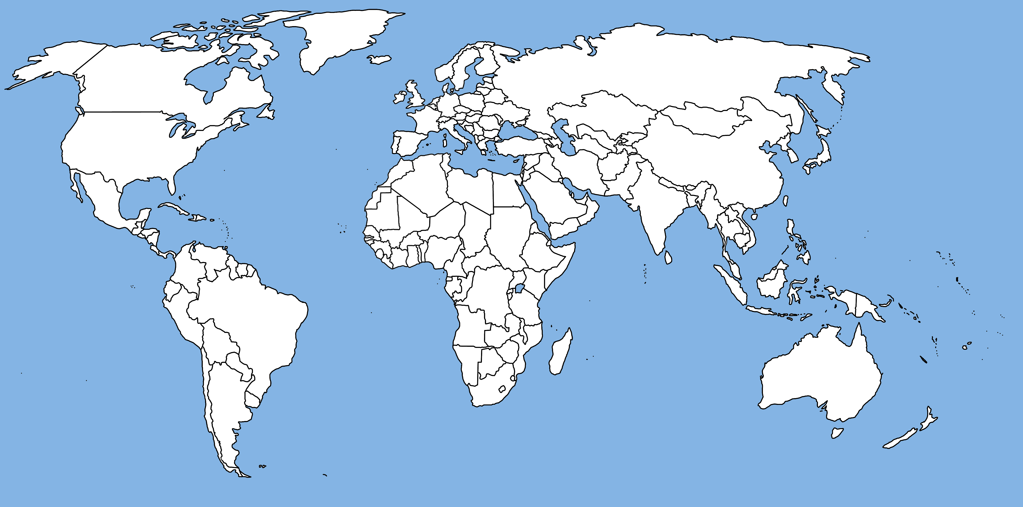
Source: http://future.wikia.com/wiki/File:10_world-map.gif

After the class discussion, we will be organising the information investigated into graphs. We will be using the continents as headings (i.e., North America, South America, Asia, Africa, Europe, Australia, Antarctica).
Thank you

