

Investigating the maths inside:

Stargazing with the SKA

Activity 2A

How big is a square kilometre?

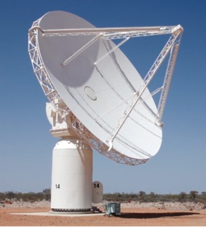

# Introduction

It is not physically possible to build a single radio telescope that covers one square kilometre. The Square Kilometre Array will be a large collection of telescopes that will combine together to cover one square kilometre.

# Making a square metre

Use four one-metre rulers to make a square metre.

Use sticky-tape and sheets of newspaper to make a square metre that can be stuck to the wall of your classroom.

How many of these squares would be required to cover one square kilometre?

Note: The diagram below is not to scale.



# A square kilometre around you

On *Google Maps* or *Google Earth* find a ‘bird’s-eye-view’ picture of your school or your house and the surrounding area, like the one below. Print it.

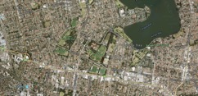

Map data ©2016 Google

Draw a square, centred on your school or house, that you estimate to be one square kilometre.

Explain how you decided how big the square should be.

Use a map or an online calculator to check the accuracy of your estimate.

# Telescope 1

The radio telescope near Parkes in NSW that featured in the movie ‘The Dish’ has a diameter of 64 metres.

1. What is the area of a circle with a diameter of 64 metres?
2. How many of these would be required to cover an area of one square kilometre in total?

# Telescope 2

The radio telescope at Tidbinbilla in the ACT was increased in size from a diameter of 64 metres to a diameter of 70 metres. Increasing a telescope’s collecting area increases its sensitivity. This means that weaker signals can be detected.

1. What is the area of a circle with diameter 70 metres?
2. When the diameter was increased by 6 metres, by what percentage did the area increase?