

Investigating the maths inside:

Bees with backpacks

Activity 3

Counting bees

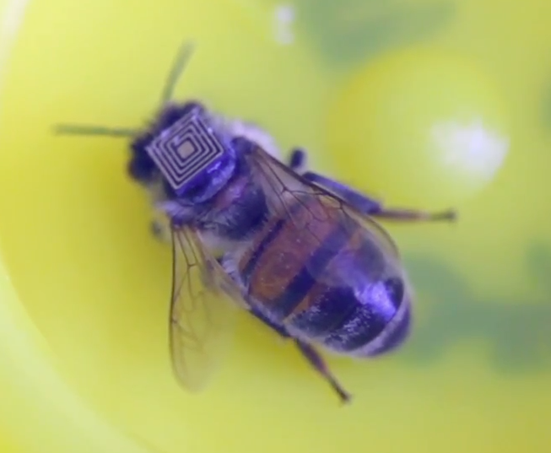

How do scientists know that bee populations are decreasing?

How could bee populations be counted?

# Introduction

It is usually impossible to count the number of animals in a population. Scientists use a variety of techniques to estimate this number. What do you think they might do?

What type of animal populations are estimated using a capture-recapture technique?

# Capture-recapture

## The experiment

Select a bag or box of ‘animals’.

Take out 30 of the animals and tag them as your teacher directs.

Put the tagged animals back in the container and mix well.

Remove 20 animals at random. How many are tagged? Record your answer.

Repeat. How many samples do you think that you will need to take to get a reliable answer?

## The analysis

Calculate the average number of tagged animals

Apply the mathematical process to estimate the population.

Empty the container and count the entire population. How close was your estimate?