

Investigating the maths inside:

Bees with backpacks

Activity 4

Clever bees

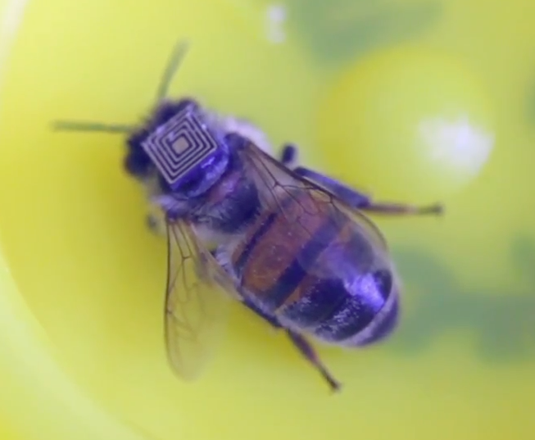

How do bees find the shortest flight path between flowering plants?

# Introduction

Because bees use lots of energy to fly, they find a route between flowers that minimises the distance they fly. What do they do to minimise the distance?

# How many ways?

To understand the difficulty of the task for the bees, it is important to understand how many different routes are possible.

|  |  |
| --- | --- |
| Number of collection points | Number of ways of visiting all collection points |
| 1 |  |
| 2 |  |
| 3 |  |
| 4 |  |

How will you record all the possible routes?

Can you find a pattern?

# Be a clever bee

You will find a hive (labelled with an X) and four flowers (labelled A, B, C and D).

Using the hive as the starting point, visit each of the four flowers, trying to find the shortest path possible. Measure the total distance. Record the route and the distance.

Repeat several times, attempting to reduce the distance each time.

How easy is it to improve?

## Is yours the shortest way?

Compare your different routes with others in the class.

Can you determine as a class what is the shortest route after comparing your different results?

## Using a network diagram

Measure the distances between all of the pairs of points X, A, B, C and D.

Draw a network of the five points showing all of the connections. Add the distances to the network diagram. You will need two copies of the network.

Your teacher will show you a tutorial video.

Use the network to attempt to find the shortest route using the Nearest Neighbour method. This will give an upper bound.

Use the network to attempt to find the shortest route using the Minimum Spanning Tree method. This will give a lower bound.

Did the algorithms give a better result than yours?

### Another flower

Add in another flower and label it E. How many possibilities are there with six points?

Use the algorithms to determine the shortest route.