Activity 3: Populations
Spread sheet instructions

A spreadsheet of the growth rate of a town
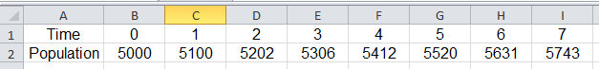

1 | Open a spreadsheet and save it with the file name Population Growth.
2 | Type the labels in Cells A1 and A2.
3 | Type 0 into Cell B1 and 1 into Cell C1 then highlight both cells.  Drag the bottom right-hand corner of C1 across the row to complete the pattern.
4 | Type 5000 into Cell B2.
5 | In Cell C2, type the formula =B2*1.02 then press the Enter key.
6 | Click on Cell C2 then drag the bottom right-hand corner of C2 across the row to complete the pattern.
7 | Use your spreadsheet to check your calculator answers.
8 | Change the number in Cell B2 to the current population of Australia.  You may need to make the columns wider.  If the population of Australia increases by 2% per annum what will it be in 50 years?

